During the 1950s, government officials were very concerned that, in the event of an atomic attack, law and order would break down irrevocably as the nation dissolved into widespread panic and hysteria. In its publicity campaigns the Federal Civil Defense Administration wanted to frighten people sufficiently to encourage them to take part in drills, but not to incapacitate them with fear. The following government-sponsored quiz appeared in the August 21, 1953 issue of Collier's magazine as a supplement to an article about human behavior during nuclear attack. It was intended to help readers from becoming "victims of panic."
Top of Form
Put a check in the column that comes closest to your reaction.

HOW DO YOU FEEL WHEN: | I'm not  bothered | I become  tense | It jars  me badly | I blow  up
1. You are alone and your doorbell and telephone ring simultaneously?
2. Someone crowds ahead of you in a line?
3. Someone near you talks persistently during a movie?
4. You’re in a room of a big building and the power goes out?
5. You arrive at a station just after your train has pulled out?
6. You are cut off during a telephone conversation?
7. You see a picture of bodies after a fatal accident?
8. A spider darts across your pillow?
9. Your car stalls, blocking traffic at a busy intersection?
10. You are alone in an elevator when it stalls between floors?

Time yourself on the next ten questions.
You should answer them in ten minutes or less.

1. Several of the letters in the following series appear more than once. Which is the first letter to be repeated?
G K Z B D F R K Z B D F R
2. The opposite of ELATED is:
punctual prescheduled saddened punctuated
3. Some of the letters in the phrase below have the same numerical order in each word that they have in the alphabet. Which are they? (Example: If one of the words were CARD, you'd pick the letter D - fourth in the word and fourth in the alphabet)
[Note: Enter letters only. Do not enter spaces or commas.]
AMPLE PREPARATION AT ONCE
4. Are these relationships true or false?
Child is to adult as colt is to horse? | TF
Cabin is to man as hangar is to aircraft? | TF
Bite is to dog as buzz is to bee? | TF
North is to south as east is to west? | TF
Arm is to hand as leg is to foot? | TF
Chicken is to food as coal is to iron? | TF
Sing is to shout as whisper is to silence? | TF

5. Some of these symbols would, if rotated, be exactly like the one in the RED box. Decide which they are, and check them.
6. A is shorter than B and taller than C, who is not as short as D. Is D shorter than A?
YES NO
7. Select the number which is incorrect in the following series.
3 5 9 17 33 67 129
8. Which of these words would look exactly the same if seen reflected in a mirror?
LETTER | GROTTO | METER
BLOTTER | ROTOR | DEFER
BETTER | OTTO | OTTER
MOTTO | DETER | FETTER
9. How many different triangles is the letter E? 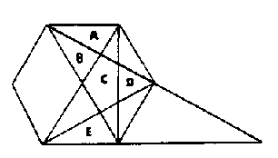
3 4 5 6 7
10. How many minutes did it take you to complete section 2?
5 6 7 8 9 10
Extend one arm, holding a heavy book or book end, or any other object weighing about three pounds. Hold your other arm behind you. Now count the words in this paragraph:

Ample preparation beforehand actually remains the only effective practical way to prevent panic during any disaster. This means a thorough educational campaign initiated long before the disaster ever starts. Training, in order to be adequate, has to be inspirational as well as informational. This is the reason why we call such preparatory training an "educational campaign." If plain people do not know what to expect in a disaster, what to do when it happens, and what to do after it happens, then panic is sure to accompany every major disaster. And whenever you have panic among people, you will always have fatal results.
How many words did you count?

Set an alarm clock ringing continously on the table near you. Then count the crosses in the circle(right) with out using a pencil to assist you. | 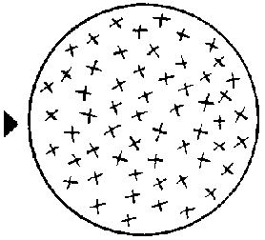  How many crosses did you count?

How long did it take you?

